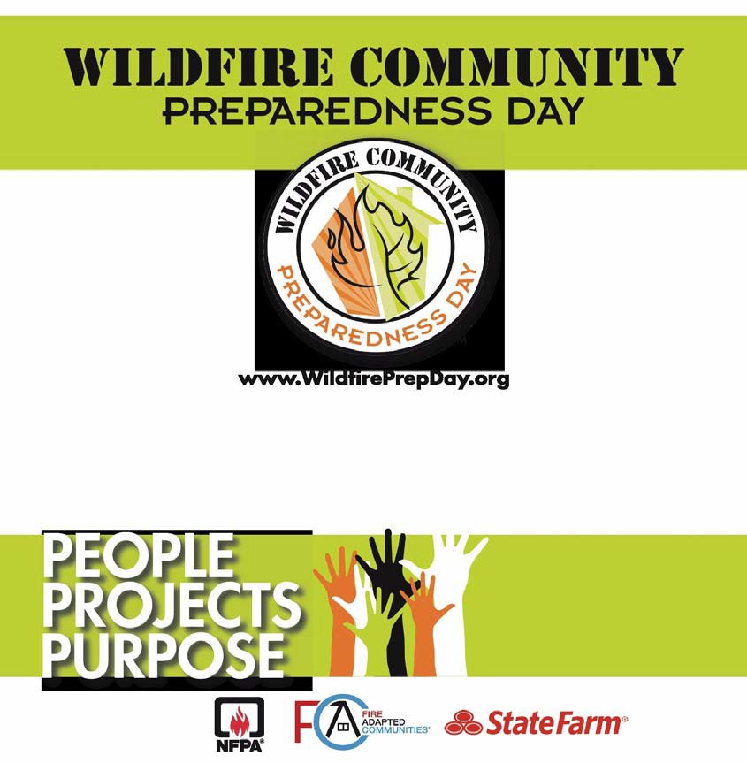
SUNDAY APRIL 27, 2014
Join others throughout
the nation making their communities a safer place
Participate in a
project that reduces our wildfire risk!
This event is sponsored by the Napa Communities Firewise
Foundation in cooperation with the Soda Canyon Fire Safe Council. For more information: www.napafirewise.org

Soda Canyon/Loma Vista Firewise Community Day and Bar-B-Q April 27, 2014 Time 3:00PM - 6:00PM
Mark your calendar to attend this important and informative event.
Meet your neighbors and enjoy some BBQ.
Learn about reducing the wildfire risk along Soda Canyon Road & Loma Vista Drive.

OPEN HOUSE 50th Anniversary of the Soda Canyon Fire Station No. 13
Location: Soda Canyon Volunteer Fire Station No. 13 2368 Soda Canyon Road
We will be discussing ways to make our community safer from wildfires and looking for volunteers to help.
There will be helpful handouts, sign-up sheets, and informative presentations and audience participation.

Please RSVP to Penny Mallen: p.mallen@me.com or 255-7556 by April 24

